# Marching Cubes算法

参考文档

|  |
| --- |
| <https://tandy123.github.io/2017/03/02/Marching-Cubes/> |
| <https://blog.csdn.net/u011426016/article/details/103140886> |
| <http://users.polytech.unice.fr/~lingrand/MarchingCubes/algo.html> |
| <http://paulbourke.net/geometry/polygonise/> |

介绍：Marching Cubes算法是三维离散数据场中提取等值面的经典算法，其主要应用于医学领域的可视化场景，例如CT扫描和MRI扫描的3D重建等。

等值面：空间中所有具有某个相同值的点的集合，可以类比为地形图里的等高线。

{(x,y,z)|f(x,y,z)=c},c是常数

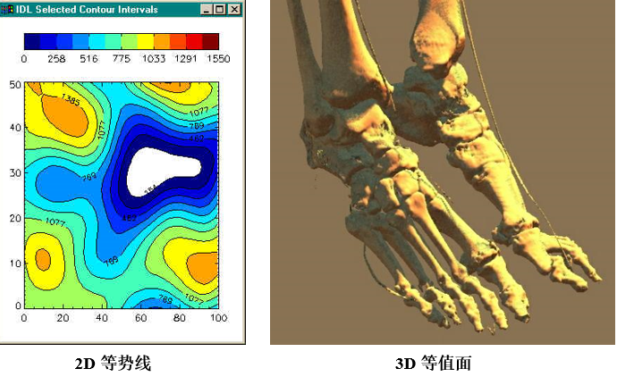

算法：

1. 逐个处理数据场中的立方体(体素)，分离出与等值面相交的立方体。
2. 得到与立方体相交的边。
3. 采用插值计算出与边的交点。
4. 根据立方体没一顶点与等值面的相对位置，将立方体边的交点按一定方式连接生成等值面。

Why？由于Marching Cubes有个基本假设：沿六面体边的数据场呈连续性变化。也就是讲，如果一条边的两个顶点分别大于或小于等值面的值，则在该条边上有且仅有一点是这条边与等值面的交点。

直观地说，就是用许多小正方体去对空间进行切分，然后用小正方体内部的平面来近似表示当前的等值面。显然，小正方体的数量越多，逼近的效果越好，随之带来的是计算的代价。

**经典Marching Cube算法的问题：**

**缺陷一：拓扑连接二义性**

**缺陷二：效率低下，需要借助分层结构和并行计算**

**改算法的发展：**Marching Tetrahedrons

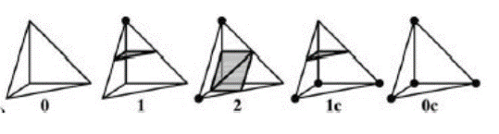

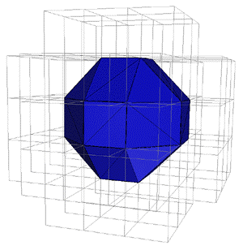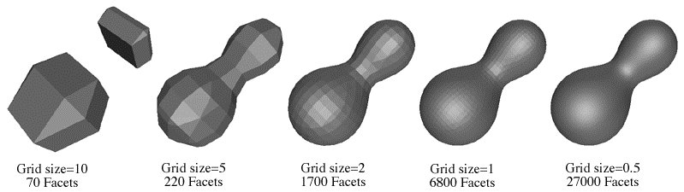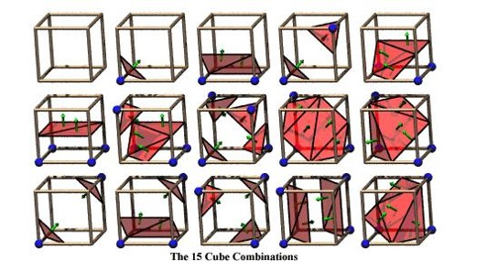

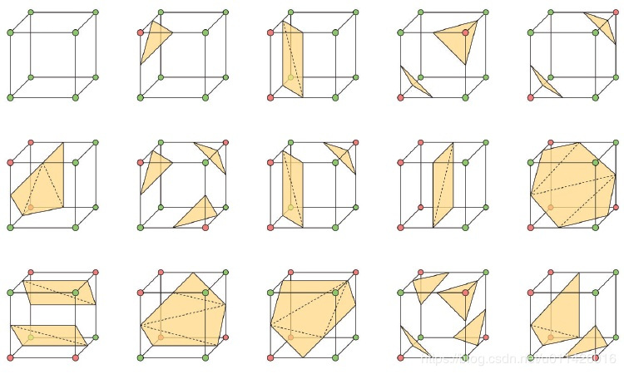

对立方体顶点，与边进行编码

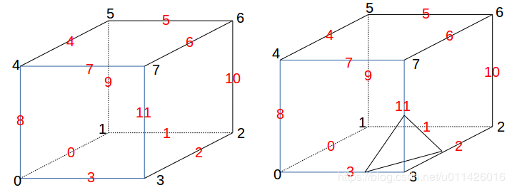

**顶点编码：**

对于立方体的每个顶点只有两种状态，要么在曲面内部，要么在曲面外部。因此对于8个顶点，我们只需要用8个二进制位就可以表示立方体的状态。我们约定，在表面内部用1表示，表面外部用0表示，第1个顶点位于二进制的最低位，第8个顶点位于二进制的最高位。

cubeindex = 0;

if (V[0] < isolevel) cubeindex |= 1;

if (V[1] < isolevel) cubeindex |= 2;

if (V[2] < isolevel) cubeindex |= 4;

if (V[3] < isolevel) cubeindex |= 8;

if (V[4] < isolevel) cubeindex |= 16;

if (V[5] < isolevel) cubeindex |= 32;

if (V[6] < isolevel) cubeindex |= 64;

if (V[7] < isolevel) cubeindex |= 128;

**边的编码：**

除了表示顶点的情况，我们还需要知道，每一种情况对应的相交面位于哪些边。

对于图1的第一种情况，所有8个顶点全在曲面外部，没有相交的边，

第二种情况，按我们的编号，只有第4个顶点在曲面内部，相交的边为4,7,8

对于图2右侧的图，只有顶点3位于内部，相交的边为2,3,11

总共就256中情况，为了简化计算，那么最简单的办法当然是查表，对于256种顶点情况，我们给出256种对应的相交边的情况，如下所示（16进制表示）。

int edgeTable[256]={

0x0 , 0x109, 0x203, 0x30a, 0x406, 0x50f, 0x605, 0x70c, 0x80c, 0x905, 0xa0f, 0xb06, 0xc0a, 0xd03, 0xe09, 0xf00,

0x190, 0x99 , 0x393, 0x29a, 0x596, 0x49f, 0x795, 0x69c, 0x99c, 0x895, 0xb9f, 0xa96, 0xd9a, 0xc93, 0xf99, 0xe90,

0x230, 0x339, 0x33 , 0x13a, 0x636, 0x73f, 0x435, 0x53c, 0xa3c, 0xb35, 0x83f, 0x936, 0xe3a, 0xf33, 0xc39, 0xd30,

0x3a0, 0x2a9, 0x1a3, 0xaa , 0x7a6, 0x6af, 0x5a5, 0x4ac, 0xbac, 0xaa5, 0x9af, 0x8a6, 0xfaa, 0xea3, 0xda9, 0xca0,

0x460, 0x569, 0x663, 0x76a, 0x66 , 0x16f, 0x265, 0x36c, 0xc6c, 0xd65, 0xe6f, 0xf66, 0x86a, 0x963, 0xa69, 0xb60,

0x5f0, 0x4f9, 0x7f3, 0x6fa, 0x1f6, 0xff , 0x3f5, 0x2fc, 0xdfc, 0xcf5, 0xfff, 0xef6, 0x9fa, 0x8f3, 0xbf9, 0xaf0,

0x650, 0x759, 0x453, 0x55a, 0x256, 0x35f, 0x55 , 0x15c, 0xe5c, 0xf55, 0xc5f, 0xd56, 0xa5a, 0xb53, 0x859, 0x950,

0x7c0, 0x6c9, 0x5c3, 0x4ca, 0x3c6, 0x2cf, 0x1c5, 0xcc , 0xfcc, 0xec5, 0xdcf, 0xcc6, 0xbca, 0xac3, 0x9c9, 0x8c0,

0x8c0, 0x9c9, 0xac3, 0xbca, 0xcc6, 0xdcf, 0xec5, 0xfcc, 0xcc , 0x1c5, 0x2cf, 0x3c6, 0x4ca, 0x5c3, 0x6c9, 0x7c0,

0x950, 0x859, 0xb53, 0xa5a, 0xd56, 0xc5f, 0xf55, 0xe5c, 0x15c, 0x55 , 0x35f, 0x256, 0x55a, 0x453, 0x759, 0x650,

0xaf0, 0xbf9, 0x8f3, 0x9fa, 0xef6, 0xfff, 0xcf5, 0xdfc, 0x2fc, 0x3f5, 0xff , 0x1f6, 0x6fa, 0x7f3, 0x4f9, 0x5f0,

0xb60, 0xa69, 0x963, 0x86a, 0xf66, 0xe6f, 0xd65, 0xc6c, 0x36c, 0x265, 0x16f, 0x66 , 0x76a, 0x663, 0x569, 0x460,

0xca0, 0xda9, 0xea3, 0xfaa, 0x8a6, 0x9af, 0xaa5, 0xbac, 0x4ac, 0x5a5, 0x6af, 0x7a6, 0xaa , 0x1a3, 0x2a9, 0x3a0,

0xd30, 0xc39, 0xf33, 0xe3a, 0x936, 0x83f, 0xb35, 0xa3c, 0x53c, 0x435, 0x73f, 0x636, 0x13a, 0x33 , 0x339, 0x230,

0xe90, 0xf99, 0xc93, 0xd9a, 0xa96, 0xb9f, 0x895, 0x99c, 0x69c, 0x795, 0x49f, 0x596, 0x29a, 0x393, 0x99 , 0x190,

0xf00, 0xe09, 0xd03, 0xc0a, 0xb06, 0xa0f, 0x905, 0x80c, 0x70c, 0x605, 0x50f, 0x406, 0x30a, 0x203, 0x109, 0x0

};

**相交的边按顺序存储**

const int tri_table[256][16] = {

{-1, -1, -1, -1, -1, -1, -1, -1, -1, -1, -1, -1, -1, -1, -1, -1},

{0, 8, 3, -1, -1, -1, -1, -1, -1, -1, -1, -1, -1, -1, -1, -1},

{0, 1, 9, -1, -1, -1, -1, -1, -1, -1, -1, -1, -1, -1, -1, -1},

{1, 8, 3, 9, 8, 1, -1, -1, -1, -1, -1, -1, -1, -1, -1, -1},

{1, 2, 10, -1, -1, -1, -1, -1, -1, -1, -1, -1, -1, -1, -1, -1},

{0, 8, 3, 1, 2, 10, -1, -1, -1, -1, -1, -1, -1, -1, -1, -1},

{9, 2, 10, 0, 2, 9, -1, -1, -1, -1, -1, -1, -1, -1, -1, -1},

{2, 8, 3, 2, 10, 8, 10, 9, 8, -1, -1, -1, -1, -1, -1, -1},

{3, 11, 2, -1, -1, -1, -1, -1, -1, -1, -1, -1, -1, -1, -1, -1},

{0, 11, 2, 8, 11, 0, -1, -1, -1, -1, -1, -1, -1, -1, -1, -1},

{1, 9, 0, 2, 3, 11, -1, -1, -1, -1, -1, -1, -1, -1, -1, -1},

{1, 11, 2, 1, 9, 11, 9, 8, 11, -1, -1, -1, -1, -1, -1, -1},

{3, 10, 1, 11, 10, 3, -1, -1, -1, -1, -1, -1, -1, -1, -1, -1},

{0, 10, 1, 0, 8, 10, 8, 11, 10, -1, -1, -1, -1, -1, -1, -1},

{3, 9, 0, 3, 11, 9, 11, 10, 9, -1, -1, -1, -1, -1, -1, -1},

{9, 8, 10, 10, 8, 11, -1, -1, -1, -1, -1, -1, -1, -1, -1, -1},

{4, 7, 8, -1, -1, -1, -1, -1, -1, -1, -1, -1, -1, -1, -1, -1},

{4, 3, 0, 7, 3, 4, -1, -1, -1, -1, -1, -1, -1, -1, -1, -1},

{0, 1, 9, 8, 4, 7, -1, -1, -1, -1, -1, -1, -1, -1, -1, -1},

{4, 1, 9, 4, 7, 1, 7, 3, 1, -1, -1, -1, -1, -1, -1, -1},

{1, 2, 10, 8, 4, 7, -1, -1, -1, -1, -1, -1, -1, -1, -1, -1},

{3, 4, 7, 3, 0, 4, 1, 2, 10, -1, -1, -1, -1, -1, -1, -1},

{9, 2, 10, 9, 0, 2, 8, 4, 7, -1, -1, -1, -1, -1, -1, -1},

{2, 10, 9, 2, 9, 7, 2, 7, 3, 7, 9, 4, -1, -1, -1, -1},

{8, 4, 7, 3, 11, 2, -1, -1, -1, -1, -1, -1, -1, -1, -1, -1},

{11, 4, 7, 11, 2, 4, 2, 0, 4, -1, -1, -1, -1, -1, -1, -1},

{9, 0, 1, 8, 4, 7, 2, 3, 11, -1, -1, -1, -1, -1, -1, -1},

{4, 7, 11, 9, 4, 11, 9, 11, 2, 9, 2, 1, -1, -1, -1, -1},

{3, 10, 1, 3, 11, 10, 7, 8, 4, -1, -1, -1, -1, -1, -1, -1},

{1, 11, 10, 1, 4, 11, 1, 0, 4, 7, 11, 4, -1, -1, -1, -1},

{4, 7, 8, 9, 0, 11, 9, 11, 10, 11, 0, 3, -1, -1, -1, -1},

{4, 7, 11, 4, 11, 9, 9, 11, 10, -1, -1, -1, -1, -1, -1, -1},

{9, 5, 4, -1, -1, -1, -1, -1, -1, -1, -1, -1, -1, -1, -1, -1},

{9, 5, 4, 0, 8, 3, -1, -1, -1, -1, -1, -1, -1, -1, -1, -1},

{0, 5, 4, 1, 5, 0, -1, -1, -1, -1, -1, -1, -1, -1, -1, -1},

{8, 5, 4, 8, 3, 5, 3, 1, 5, -1, -1, -1, -1, -1, -1, -1},

{1, 2, 10, 9, 5, 4, -1, -1, -1, -1, -1, -1, -1, -1, -1, -1},

{3, 0, 8, 1, 2, 10, 4, 9, 5, -1, -1, -1, -1, -1, -1, -1},

{5, 2, 10, 5, 4, 2, 4, 0, 2, -1, -1, -1, -1, -1, -1, -1},

{2, 10, 5, 3, 2, 5, 3, 5, 4, 3, 4, 8, -1, -1, -1, -1},

{9, 5, 4, 2, 3, 11, -1, -1, -1, -1, -1, -1, -1, -1, -1, -1},

{0, 11, 2, 0, 8, 11, 4, 9, 5, -1, -1, -1, -1, -1, -1, -1},

{0, 5, 4, 0, 1, 5, 2, 3, 11, -1, -1, -1, -1, -1, -1, -1},

{2, 1, 5, 2, 5, 8, 2, 8, 11, 4, 8, 5, -1, -1, -1, -1},

{10, 3, 11, 10, 1, 3, 9, 5, 4, -1, -1, -1, -1, -1, -1, -1},

{4, 9, 5, 0, 8, 1, 8, 10, 1, 8, 11, 10, -1, -1, -1, -1},

{5, 4, 0, 5, 0, 11, 5, 11, 10, 11, 0, 3, -1, -1, -1, -1},

{5, 4, 8, 5, 8, 10, 10, 8, 11, -1, -1, -1, -1, -1, -1, -1},

{9, 7, 8, 5, 7, 9, -1, -1, -1, -1, -1, -1, -1, -1, -1, -1},

{9, 3, 0, 9, 5, 3, 5, 7, 3, -1, -1, -1, -1, -1, -1, -1},

{0, 7, 8, 0, 1, 7, 1, 5, 7, -1, -1, -1, -1, -1, -1, -1},

{1, 5, 3, 3, 5, 7, -1, -1, -1, -1, -1, -1, -1, -1, -1, -1},

{9, 7, 8, 9, 5, 7, 10, 1, 2, -1, -1, -1, -1, -1, -1, -1},

{10, 1, 2, 9, 5, 0, 5, 3, 0, 5, 7, 3, -1, -1, -1, -1},

{8, 0, 2, 8, 2, 5, 8, 5, 7, 10, 5, 2, -1, -1, -1, -1},

{2, 10, 5, 2, 5, 3, 3, 5, 7, -1, -1, -1, -1, -1, -1, -1},

{7, 9, 5, 7, 8, 9, 3, 11, 2, -1, -1, -1, -1, -1, -1, -1},

{9, 5, 7, 9, 7, 2, 9, 2, 0, 2, 7, 11, -1, -1, -1, -1},

{2, 3, 11, 0, 1, 8, 1, 7, 8, 1, 5, 7, -1, -1, -1, -1},

{11, 2, 1, 11, 1, 7, 7, 1, 5, -1, -1, -1, -1, -1, -1, -1},

{9, 5, 8, 8, 5, 7, 10, 1, 3, 10, 3, 11, -1, -1, -1, -1},

{5, 7, 0, 5, 0, 9, 7, 11, 0, 1, 0, 10, 11, 10, 0, -1},

{11, 10, 0, 11, 0, 3, 10, 5, 0, 8, 0, 7, 5, 7, 0, -1},

{11, 10, 5, 7, 11, 5, -1, -1, -1, -1, -1, -1, -1, -1, -1, -1},

{10, 6, 5, -1, -1, -1, -1, -1, -1, -1, -1, -1, -1, -1, -1, -1},

{0, 8, 3, 5, 10, 6, -1, -1, -1, -1, -1, -1, -1, -1, -1, -1},

{9, 0, 1, 5, 10, 6, -1, -1, -1, -1, -1, -1, -1, -1, -1, -1},

{1, 8, 3, 1, 9, 8, 5, 10, 6, -1, -1, -1, -1, -1, -1, -1},

{1, 6, 5, 2, 6, 1, -1, -1, -1, -1, -1, -1, -1, -1, -1, -1},

{1, 6, 5, 1, 2, 6, 3, 0, 8, -1, -1, -1, -1, -1, -1, -1},

{9, 6, 5, 9, 0, 6, 0, 2, 6, -1, -1, -1, -1, -1, -1, -1},

{5, 9, 8, 5, 8, 2, 5, 2, 6, 3, 2, 8, -1, -1, -1, -1},

{2, 3, 11, 10, 6, 5, -1, -1, -1, -1, -1, -1, -1, -1, -1, -1},

{11, 0, 8, 11, 2, 0, 10, 6, 5, -1, -1, -1, -1, -1, -1, -1},

{0, 1, 9, 2, 3, 11, 5, 10, 6, -1, -1, -1, -1, -1, -1, -1},

{5, 10, 6, 1, 9, 2, 9, 11, 2, 9, 8, 11, -1, -1, -1, -1},

{6, 3, 11, 6, 5, 3, 5, 1, 3, -1, -1, -1, -1, -1, -1, -1},

{0, 8, 11, 0, 11, 5, 0, 5, 1, 5, 11, 6, -1, -1, -1, -1},

{3, 11, 6, 0, 3, 6, 0, 6, 5, 0, 5, 9, -1, -1, -1, -1},

{6, 5, 9, 6, 9, 11, 11, 9, 8, -1, -1, -1, -1, -1, -1, -1},

{5, 10, 6, 4, 7, 8, -1, -1, -1, -1, -1, -1, -1, -1, -1, -1},

{4, 3, 0, 4, 7, 3, 6, 5, 10, -1, -1, -1, -1, -1, -1, -1},

{1, 9, 0, 5, 10, 6, 8, 4, 7, -1, -1, -1, -1, -1, -1, -1},

{10, 6, 5, 1, 9, 7, 1, 7, 3, 7, 9, 4, -1, -1, -1, -1},

{6, 1, 2, 6, 5, 1, 4, 7, 8, -1, -1, -1, -1, -1, -1, -1},

{1, 2, 5, 5, 2, 6, 3, 0, 4, 3, 4, 7, -1, -1, -1, -1},

{8, 4, 7, 9, 0, 5, 0, 6, 5, 0, 2, 6, -1, -1, -1, -1},

{7, 3, 9, 7, 9, 4, 3, 2, 9, 5, 9, 6, 2, 6, 9, -1},

{3, 11, 2, 7, 8, 4, 10, 6, 5, -1, -1, -1, -1, -1, -1, -1},

{5, 10, 6, 4, 7, 2, 4, 2, 0, 2, 7, 11, -1, -1, -1, -1},

{0, 1, 9, 4, 7, 8, 2, 3, 11, 5, 10, 6, -1, -1, -1, -1},

{9, 2, 1, 9, 11, 2, 9, 4, 11, 7, 11, 4, 5, 10, 6, -1},

{8, 4, 7, 3, 11, 5, 3, 5, 1, 5, 11, 6, -1, -1, -1, -1},

{5, 1, 11, 5, 11, 6, 1, 0, 11, 7, 11, 4, 0, 4, 11, -1},

{0, 5, 9, 0, 6, 5, 0, 3, 6, 11, 6, 3, 8, 4, 7, -1},

{6, 5, 9, 6, 9, 11, 4, 7, 9, 7, 11, 9, -1, -1, -1, -1},

{10, 4, 9, 6, 4, 10, -1, -1, -1, -1, -1, -1, -1, -1, -1, -1},

{4, 10, 6, 4, 9, 10, 0, 8, 3, -1, -1, -1, -1, -1, -1, -1},

{10, 0, 1, 10, 6, 0, 6, 4, 0, -1, -1, -1, -1, -1, -1, -1},

{8, 3, 1, 8, 1, 6, 8, 6, 4, 6, 1, 10, -1, -1, -1, -1},

{1, 4, 9, 1, 2, 4, 2, 6, 4, -1, -1, -1, -1, -1, -1, -1},

{3, 0, 8, 1, 2, 9, 2, 4, 9, 2, 6, 4, -1, -1, -1, -1},

{0, 2, 4, 4, 2, 6, -1, -1, -1, -1, -1, -1, -1, -1, -1, -1},

{8, 3, 2, 8, 2, 4, 4, 2, 6, -1, -1, -1, -1, -1, -1, -1},

{10, 4, 9, 10, 6, 4, 11, 2, 3, -1, -1, -1, -1, -1, -1, -1},

{0, 8, 2, 2, 8, 11, 4, 9, 10, 4, 10, 6, -1, -1, -1, -1},

{3, 11, 2, 0, 1, 6, 0, 6, 4, 6, 1, 10, -1, -1, -1, -1},

{6, 4, 1, 6, 1, 10, 4, 8, 1, 2, 1, 11, 8, 11, 1, -1},

{9, 6, 4, 9, 3, 6, 9, 1, 3, 11, 6, 3, -1, -1, -1, -1},

{8, 11, 1, 8, 1, 0, 11, 6, 1, 9, 1, 4, 6, 4, 1, -1},

{3, 11, 6, 3, 6, 0, 0, 6, 4, -1, -1, -1, -1, -1, -1, -1},

{6, 4, 8, 11, 6, 8, -1, -1, -1, -1, -1, -1, -1, -1, -1, -1},

{7, 10, 6, 7, 8, 10, 8, 9, 10, -1, -1, -1, -1, -1, -1, -1},

{0, 7, 3, 0, 10, 7, 0, 9, 10, 6, 7, 10, -1, -1, -1, -1},

{10, 6, 7, 1, 10, 7, 1, 7, 8, 1, 8, 0, -1, -1, -1, -1},

{10, 6, 7, 10, 7, 1, 1, 7, 3, -1, -1, -1, -1, -1, -1, -1},

{1, 2, 6, 1, 6, 8, 1, 8, 9, 8, 6, 7, -1, -1, -1, -1},

{2, 6, 9, 2, 9, 1, 6, 7, 9, 0, 9, 3, 7, 3, 9, -1},

{7, 8, 0, 7, 0, 6, 6, 0, 2, -1, -1, -1, -1, -1, -1, -1},

{7, 3, 2, 6, 7, 2, -1, -1, -1, -1, -1, -1, -1, -1, -1, -1},

{2, 3, 11, 10, 6, 8, 10, 8, 9, 8, 6, 7, -1, -1, -1, -1},

{2, 0, 7, 2, 7, 11, 0, 9, 7, 6, 7, 10, 9, 10, 7, -1},

{1, 8, 0, 1, 7, 8, 1, 10, 7, 6, 7, 10, 2, 3, 11, -1},

{11, 2, 1, 11, 1, 7, 10, 6, 1, 6, 7, 1, -1, -1, -1, -1},

{8, 9, 6, 8, 6, 7, 9, 1, 6, 11, 6, 3, 1, 3, 6, -1},

{0, 9, 1, 11, 6, 7, -1, -1, -1, -1, -1, -1, -1, -1, -1, -1},

{7, 8, 0, 7, 0, 6, 3, 11, 0, 11, 6, 0, -1, -1, -1, -1},

{7, 11, 6, -1, -1, -1, -1, -1, -1, -1, -1, -1, -1, -1, -1, -1},

{7, 6, 11, -1, -1, -1, -1, -1, -1, -1, -1, -1, -1, -1, -1, -1},

{3, 0, 8, 11, 7, 6, -1, -1, -1, -1, -1, -1, -1, -1, -1, -1},

{0, 1, 9, 11, 7, 6, -1, -1, -1, -1, -1, -1, -1, -1, -1, -1},

{8, 1, 9, 8, 3, 1, 11, 7, 6, -1, -1, -1, -1, -1, -1, -1},

{10, 1, 2, 6, 11, 7, -1, -1, -1, -1, -1, -1, -1, -1, -1, -1},

{1, 2, 10, 3, 0, 8, 6, 11, 7, -1, -1, -1, -1, -1, -1, -1},

{2, 9, 0, 2, 10, 9, 6, 11, 7, -1, -1, -1, -1, -1, -1, -1},

{6, 11, 7, 2, 10, 3, 10, 8, 3, 10, 9, 8, -1, -1, -1, -1},

{7, 2, 3, 6, 2, 7, -1, -1, -1, -1, -1, -1, -1, -1, -1, -1},

{7, 0, 8, 7, 6, 0, 6, 2, 0, -1, -1, -1, -1, -1, -1, -1},

{2, 7, 6, 2, 3, 7, 0, 1, 9, -1, -1, -1, -1, -1, -1, -1},

{1, 6, 2, 1, 8, 6, 1, 9, 8, 8, 7, 6, -1, -1, -1, -1},

{10, 7, 6, 10, 1, 7, 1, 3, 7, -1, -1, -1, -1, -1, -1, -1},

{10, 7, 6, 1, 7, 10, 1, 8, 7, 1, 0, 8, -1, -1, -1, -1},

{0, 3, 7, 0, 7, 10, 0, 10, 9, 6, 10, 7, -1, -1, -1, -1},

{7, 6, 10, 7, 10, 8, 8, 10, 9, -1, -1, -1, -1, -1, -1, -1},

{6, 8, 4, 11, 8, 6, -1, -1, -1, -1, -1, -1, -1, -1, -1, -1},

{3, 6, 11, 3, 0, 6, 0, 4, 6, -1, -1, -1, -1, -1, -1, -1},

{8, 6, 11, 8, 4, 6, 9, 0, 1, -1, -1, -1, -1, -1, -1, -1},

{9, 4, 6, 9, 6, 3, 9, 3, 1, 11, 3, 6, -1, -1, -1, -1},

{6, 8, 4, 6, 11, 8, 2, 10, 1, -1, -1, -1, -1, -1, -1, -1},

{1, 2, 10, 3, 0, 11, 0, 6, 11, 0, 4, 6, -1, -1, -1, -1},

{4, 11, 8, 4, 6, 11, 0, 2, 9, 2, 10, 9, -1, -1, -1, -1},

{10, 9, 3, 10, 3, 2, 9, 4, 3, 11, 3, 6, 4, 6, 3, -1},

{8, 2, 3, 8, 4, 2, 4, 6, 2, -1, -1, -1, -1, -1, -1, -1},

{0, 4, 2, 4, 6, 2, -1, -1, -1, -1, -1, -1, -1, -1, -1, -1},

{1, 9, 0, 2, 3, 4, 2, 4, 6, 4, 3, 8, -1, -1, -1, -1},

{1, 9, 4, 1, 4, 2, 2, 4, 6, -1, -1, -1, -1, -1, -1, -1},

{8, 1, 3, 8, 6, 1, 8, 4, 6, 6, 10, 1, -1, -1, -1, -1},

{10, 1, 0, 10, 0, 6, 6, 0, 4, -1, -1, -1, -1, -1, -1, -1},

{4, 6, 3, 4, 3, 8, 6, 10, 3, 0, 3, 9, 10, 9, 3, -1},

{10, 9, 4, 6, 10, 4, -1, -1, -1, -1, -1, -1, -1, -1, -1, -1},

{4, 9, 5, 7, 6, 11, -1, -1, -1, -1, -1, -1, -1, -1, -1, -1},

{0, 8, 3, 4, 9, 5, 11, 7, 6, -1, -1, -1, -1, -1, -1, -1},

{5, 0, 1, 5, 4, 0, 7, 6, 11, -1, -1, -1, -1, -1, -1, -1},

{11, 7, 6, 8, 3, 4, 3, 5, 4, 3, 1, 5, -1, -1, -1, -1},

{9, 5, 4, 10, 1, 2, 7, 6, 11, -1, -1, -1, -1, -1, -1, -1},

{6, 11, 7, 1, 2, 10, 0, 8, 3, 4, 9, 5, -1, -1, -1, -1},

{7, 6, 11, 5, 4, 10, 4, 2, 10, 4, 0, 2, -1, -1, -1, -1},

{3, 4, 8, 3, 5, 4, 3, 2, 5, 10, 5, 2, 11, 7, 6, -1},

{7, 2, 3, 7, 6, 2, 5, 4, 9, -1, -1, -1, -1, -1, -1, -1},

{9, 5, 4, 0, 8, 6, 0, 6, 2, 6, 8, 7, -1, -1, -1, -1},

{3, 6, 2, 3, 7, 6, 1, 5, 0, 5, 4, 0, -1, -1, -1, -1},

{6, 2, 8, 6, 8, 7, 2, 1, 8, 4, 8, 5, 1, 5, 8, -1},

{9, 5, 4, 10, 1, 6, 1, 7, 6, 1, 3, 7, -1, -1, -1, -1},

{1, 6, 10, 1, 7, 6, 1, 0, 7, 8, 7, 0, 9, 5, 4, -1},

{4, 0, 10, 4, 10, 5, 0, 3, 10, 6, 10, 7, 3, 7, 10, -1},

{7, 6, 10, 7, 10, 8, 5, 4, 10, 4, 8, 10, -1, -1, -1, -1},

{6, 9, 5, 6, 11, 9, 11, 8, 9, -1, -1, -1, -1, -1, -1, -1},

{3, 6, 11, 0, 6, 3, 0, 5, 6, 0, 9, 5, -1, -1, -1, -1},

{0, 11, 8, 0, 5, 11, 0, 1, 5, 5, 6, 11, -1, -1, -1, -1},

{6, 11, 3, 6, 3, 5, 5, 3, 1, -1, -1, -1, -1, -1, -1, -1},

{1, 2, 10, 9, 5, 11, 9, 11, 8, 11, 5, 6, -1, -1, -1, -1},

{0, 11, 3, 0, 6, 11, 0, 9, 6, 5, 6, 9, 1, 2, 10, -1},

{11, 8, 5, 11, 5, 6, 8, 0, 5, 10, 5, 2, 0, 2, 5, -1},

{6, 11, 3, 6, 3, 5, 2, 10, 3, 10, 5, 3, -1, -1, -1, -1},

{5, 8, 9, 5, 2, 8, 5, 6, 2, 3, 8, 2, -1, -1, -1, -1},

{9, 5, 6, 9, 6, 0, 0, 6, 2, -1, -1, -1, -1, -1, -1, -1},

{1, 5, 8, 1, 8, 0, 5, 6, 8, 3, 8, 2, 6, 2, 8, -1},

{1, 5, 6, 2, 1, 6, -1, -1, -1, -1, -1, -1, -1, -1, -1, -1},

{1, 3, 6, 1, 6, 10, 3, 8, 6, 5, 6, 9, 8, 9, 6, -1},

{10, 1, 0, 10, 0, 6, 9, 5, 0, 5, 6, 0, -1, -1, -1, -1},

{0, 3, 8, 5, 6, 10, -1, -1, -1, -1, -1, -1, -1, -1, -1, -1},

{10, 5, 6, -1, -1, -1, -1, -1, -1, -1, -1, -1, -1, -1, -1, -1},

{11, 5, 10, 7, 5, 11, -1, -1, -1, -1, -1, -1, -1, -1, -1, -1},

{11, 5, 10, 11, 7, 5, 8, 3, 0, -1, -1, -1, -1, -1, -1, -1},

{5, 11, 7, 5, 10, 11, 1, 9, 0, -1, -1, -1, -1, -1, -1, -1},

{10, 7, 5, 10, 11, 7, 9, 8, 1, 8, 3, 1, -1, -1, -1, -1},

{11, 1, 2, 11, 7, 1, 7, 5, 1, -1, -1, -1, -1, -1, -1, -1},

{0, 8, 3, 1, 2, 7, 1, 7, 5, 7, 2, 11, -1, -1, -1, -1},

{9, 7, 5, 9, 2, 7, 9, 0, 2, 2, 11, 7, -1, -1, -1, -1},

{7, 5, 2, 7, 2, 11, 5, 9, 2, 3, 2, 8, 9, 8, 2, -1},

{2, 5, 10, 2, 3, 5, 3, 7, 5, -1, -1, -1, -1, -1, -1, -1},

{8, 2, 0, 8, 5, 2, 8, 7, 5, 10, 2, 5, -1, -1, -1, -1},

{9, 0, 1, 5, 10, 3, 5, 3, 7, 3, 10, 2, -1, -1, -1, -1},

{9, 8, 2, 9, 2, 1, 8, 7, 2, 10, 2, 5, 7, 5, 2, -1},

{1, 3, 5, 3, 7, 5, -1, -1, -1, -1, -1, -1, -1, -1, -1, -1},

{0, 8, 7, 0, 7, 1, 1, 7, 5, -1, -1, -1, -1, -1, -1, -1},

{9, 0, 3, 9, 3, 5, 5, 3, 7, -1, -1, -1, -1, -1, -1, -1},

{9, 8, 7, 5, 9, 7, -1, -1, -1, -1, -1, -1, -1, -1, -1, -1},

{5, 8, 4, 5, 10, 8, 10, 11, 8, -1, -1, -1, -1, -1, -1, -1},

{5, 0, 4, 5, 11, 0, 5, 10, 11, 11, 3, 0, -1, -1, -1, -1},

{0, 1, 9, 8, 4, 10, 8, 10, 11, 10, 4, 5, -1, -1, -1, -1},

{10, 11, 4, 10, 4, 5, 11, 3, 4, 9, 4, 1, 3, 1, 4, -1},

{2, 5, 1, 2, 8, 5, 2, 11, 8, 4, 5, 8, -1, -1, -1, -1},

{0, 4, 11, 0, 11, 3, 4, 5, 11, 2, 11, 1, 5, 1, 11, -1},

{0, 2, 5, 0, 5, 9, 2, 11, 5, 4, 5, 8, 11, 8, 5, -1},

{9, 4, 5, 2, 11, 3, -1, -1, -1, -1, -1, -1, -1, -1, -1, -1},

{2, 5, 10, 3, 5, 2, 3, 4, 5, 3, 8, 4, -1, -1, -1, -1},

{5, 10, 2, 5, 2, 4, 4, 2, 0, -1, -1, -1, -1, -1, -1, -1},

{3, 10, 2, 3, 5, 10, 3, 8, 5, 4, 5, 8, 0, 1, 9, -1},

{5, 10, 2, 5, 2, 4, 1, 9, 2, 9, 4, 2, -1, -1, -1, -1},

{8, 4, 5, 8, 5, 3, 3, 5, 1, -1, -1, -1, -1, -1, -1, -1},

{0, 4, 5, 1, 0, 5, -1, -1, -1, -1, -1, -1, -1, -1, -1, -1},

{8, 4, 5, 8, 5, 3, 9, 0, 5, 0, 3, 5, -1, -1, -1, -1},

{9, 4, 5, -1, -1, -1, -1, -1, -1, -1, -1, -1, -1, -1, -1, -1},

{4, 11, 7, 4, 9, 11, 9, 10, 11, -1, -1, -1, -1, -1, -1, -1},

{0, 8, 3, 4, 9, 7, 9, 11, 7, 9, 10, 11, -1, -1, -1, -1},

{1, 10, 11, 1, 11, 4, 1, 4, 0, 7, 4, 11, -1, -1, -1, -1},

{3, 1, 4, 3, 4, 8, 1, 10, 4, 7, 4, 11, 10, 11, 4, -1},

{4, 11, 7, 9, 11, 4, 9, 2, 11, 9, 1, 2, -1, -1, -1, -1},

{9, 7, 4, 9, 11, 7, 9, 1, 11, 2, 11, 1, 0, 8, 3, -1},

{11, 7, 4, 11, 4, 2, 2, 4, 0, -1, -1, -1, -1, -1, -1, -1},

{11, 7, 4, 11, 4, 2, 8, 3, 4, 3, 2, 4, -1, -1, -1, -1},

{2, 9, 10, 2, 7, 9, 2, 3, 7, 7, 4, 9, -1, -1, -1, -1},

{9, 10, 7, 9, 7, 4, 10, 2, 7, 8, 7, 0, 2, 0, 7, -1},

{3, 7, 10, 3, 10, 2, 7, 4, 10, 1, 10, 0, 4, 0, 10, -1},

{1, 10, 2, 8, 7, 4, -1, -1, -1, -1, -1, -1, -1, -1, -1, -1},

{4, 9, 1, 4, 1, 7, 7, 1, 3, -1, -1, -1, -1, -1, -1, -1},

{4, 9, 1, 4, 1, 7, 0, 8, 1, 8, 7, 1, -1, -1, -1, -1},

{4, 0, 3, 7, 4, 3, -1, -1, -1, -1, -1, -1, -1, -1, -1, -1},

{4, 8, 7, -1, -1, -1, -1, -1, -1, -1, -1, -1, -1, -1, -1, -1},

{9, 10, 8, 10, 11, 8, -1, -1, -1, -1, -1, -1, -1, -1, -1, -1},

{3, 0, 9, 3, 9, 11, 11, 9, 10, -1, -1, -1, -1, -1, -1, -1},

{0, 1, 10, 0, 10, 8, 8, 10, 11, -1, -1, -1, -1, -1, -1, -1},

{3, 1, 10, 11, 3, 10, -1, -1, -1, -1, -1, -1, -1, -1, -1, -1},

{1, 2, 11, 1, 11, 9, 9, 11, 8, -1, -1, -1, -1, -1, -1, -1},

{3, 0, 9, 3, 9, 11, 1, 2, 9, 2, 11, 9, -1, -1, -1, -1},

{0, 2, 11, 8, 0, 11, -1, -1, -1, -1, -1, -1, -1, -1, -1, -1},

{3, 2, 11, -1, -1, -1, -1, -1, -1, -1, -1, -1, -1, -1, -1, -1},

{2, 3, 8, 2, 8, 10, 10, 8, 9, -1, -1, -1, -1, -1, -1, -1},

{9, 10, 2, 0, 9, 2, -1, -1, -1, -1, -1, -1, -1, -1, -1, -1},

{2, 3, 8, 2, 8, 10, 0, 1, 8, 1, 10, 8, -1, -1, -1, -1},

{1, 10, 2, -1, -1, -1, -1, -1, -1, -1, -1, -1, -1, -1, -1, -1},

{1, 3, 8, 9, 1, 8, -1, -1, -1, -1, -1, -1, -1, -1, -1, -1},

{0, 9, 1, -1, -1, -1, -1, -1, -1, -1, -1, -1, -1, -1, -1, -1},

{0, 3, 8, -1, -1, -1, -1, -1, -1, -1, -1, -1, -1, -1, -1, -1},

{-1, -1, -1, -1, -1, -1, -1, -1, -1, -1, -1, -1, -1, -1, -1, -1}};